Report on

Safe Air Detector

Submitted to:

University Institute of Computing

Submitted by:

Ayushi Chauhan (24MCI10038)
Anuj (24MCI10020)



Chandigarh University, Mohali

Github:- https://github.com/anujdhiman28/Safe-Air-Detector-.git

Table Of Content
CHAPTER1: INTRODUCTION……………………………………………………………..…..1-2
1.1 Need Identification
1.2 Identification of problem
1.3 Identification of tasks
1.4 Timeline
1.5 Organization of the report

CHAPTER 2: BACKGROUND STUDY……………………………………………………...3-4
2.1. Timeline of the reported problem
2.2 Proposed Solution
2.3 Bibliometric analysis
2.4 Review Summary
2.5 Problem Definition
2.6 goals/ Objective
2.7 Why Use Technologies Over Other

CHAPTER 3: DESIGN AND PROCESS………………………………………………………5-11
3.1 Evaluation & Selection of Specifications/Features
3.2 Design Constraints
3.3 Design Flow
3.4 Logo Designing and Naming
3.5 Implementation plan/methodology
3.6 Project output

CHAPTER 4: RESULT ANALYSIS AND VALIDATION………………………………………12-14
4.1 Implementation of solution
4.1.1 Report preparation,
4.1.2 Project management, and communication
4.1.3 Testing/characterization/interpretation/data validation.

CHAPTER 5: CONCLUSION AND FUTURE WORK……………..……………………….15-16
5.1 Conclusion
5.2 Future Work

REFERENCES

ABSTRACT

Gas leaks can be extremely dangerous, often leading to fire accidents or even explosions if not detected early. To address this problem, our project focuses on developing a simple and affordable MQ2 Gas Detection System using Arduino Uno. The main idea behind the system is to continuously monitor the air for harmful or flammable gases such as LPG, methane, propane, and hydrogen, and alert the user before the situation becomes hazardous.
The system uses the MQ2 sensor, which senses gas concentrations and sends signals to the Arduino. Based on these readings, the Arduino compares the values with a set threshold. If the gas level crosses the safe limit, a red LED and buzzer turn on to immediately warn the user, while a green LED glows during safe conditions. The circuit was designed and tested using Tinkercad, and later verified through real-time experiments by exposing the sensor to small amounts of lighter gas. The results showed that the sensor responded quickly and accurately — normal air readings were around 200–300, and values above 400 triggered the alarm system.
This project demonstrates how embedded systems and sensors can be combined to improve everyday safety. It is cost-effective, easy to build, and suitable for homes, small workshops, and educational labs. In the future, the project can be enhanced by adding Wi-Fi or GSM modules for mobile alerts, an LCD display for real-time readings, and even IoT connectivity for remote monitoring. Overall, the MQ2 Gas Detection System is a practical step toward making our surroundings safer and smarter.

CHAPTER 1 INTRODUCTION

1.1.Need Identification
With rapid urbanization and increasing dependence on fuel gases like LPG, methane, and propane, the chances of accidental gas leaks in homes, restaurants, and industries have also grown. A single unnoticed leak can lead to serious accidents, fires, and even explosions. Although commercial gas detectors exist, many of them are either expensive or not easily available in rural and semi-urban areas.
Hence, there is a growing need for an affordable, reliable, and real-time gas detection system that can alert people before the gas concentration reaches a dangerous level. The MQ2 gas sensor, when integrated with Arduino Uno, offers a low-cost solution to this problem. This system can sense the presence of combustible gases and provide instant warnings through LEDs and a buzzer, allowing people to take preventive actions.
The project, therefore, aims to design and implement a Gas Leakage Detection System using the MQ2 sensor and Arduino, which continuously monitors air quality and alerts users in case of danger.

1.2.Identification of Problem
In households and industries, LPG and other combustible gases are frequently used for cooking and heating. Despite their benefits, these gases are highly flammable and can easily cause accidents if leaked. The problem is that such leaks often go unnoticed since the gases are colorless and sometimes odorless. Traditional detection methods, such as manual checks, are ineffective.
Many households rely solely on human sense of smell or on commercial detectors that may not be affordable for everyone. Moreover, gas leakage incidents can occur even when people are away from home, increasing the risk. Thus, the main problem identified is:
How to create a low-cost, simple, and reliable gas detection system that can immediately alert users to the presence of combustible gases?
This project directly addresses that issue through a small, automatic detection system that anyone can build and install.

1.3.Identification of Tasks
To tackle the problem effectively, several key tasks were identified and executed systematically:
- Study the working principle and calibration of the MQ2 gas sensor.
- Understand Arduino Uno pin configuration and analog data reading.
- Design an electronic circuit to interface the MQ2 sensor with Arduino, LEDs, and a buzzer.
- Write Arduino code for continuous gas monitoring, alerting, and serial output.
- Test and calibrate the system to set a safe and accurate threshold value.
- Validate results under simulated gas leak conditions using lighter gas or incense smoke.

1.4.Timeline
Week | Task | Description
Week 1–2 | Research & Literature Review | Studied gas leakage incidents, existing detection systems, and MQ sensor series.
Week 3–4 | Component Selection | Chose Arduino Uno, MQ2 sensor, buzzer, LEDs, resistors, and breadboard.
Week 5 | Circuit Design | Created and simulated circuit using Tinkercad. Verified connections.
Week 6 | Code Development | Wrote and uploaded Arduino program for gas detection.
Week 7 | Testing & Calibration | Tested with real gas sources and adjusted threshold for accuracy.
Week 8 | Documentation | Prepared final report, diagrams, and analysis.

1.5.Organization of the Report
The report is structured as follows:
- Chapter 1: Introduction — Provides the background, need, problem, and project scope.
- Chapter 2: Background Study — Reviews existing research, solutions, and proposed system.
- Chapter 3: Design and Process — Explains circuit, components, design flow, and implementation.
- Chapter 4: Result and Validation — Discusses testing outcomes and data analysis.
- Chapter 5: Conclusion and Future Work — Summarizes findings and suggests improvements.

CHAPTER 2 BACKGROUND STUDY

2.1. Timeline of the Reported Problem
In the last decade, India and other countries have witnessed several gas-related accidents due to unnoticed leaks. Common reasons include faulty pipes, worn-out regulators, and negligence. Statistics from safety reports show that the majority of these incidents could have been prevented if an early detection system had been installed.
Technological advancements now make it possible to use low-cost sensors and microcontrollers to continuously monitor air quality, detect gases, and alert users. The MQ2 sensor is widely recognized for its sensitivity to LPG, propane, methane, and smoke, which makes it ideal for this purpose.

2.2. Proposed Solution
The proposed solution is a real-time gas leakage detection system based on the MQ2 sensor and Arduino Uno. The MQ2 sensor’s analog output voltage varies with gas concentration in the surrounding air. Arduino reads this analog signal and compares it to a predefined threshold value.
- If the reading exceeds the threshold → Danger condition: Red LED and buzzer turn ON.
- If the reading is below the threshold → Safe condition: Green LED remains ON.
This setup ensures quick and direct feedback without requiring complex systems or internet connectivity, making it ideal for low-budget safety applications.

2.3. Bibliometric Analysis

Several studies and research papers emphasize the importance of gas detection in industrial and domestic environments. The MQ series of sensors (especially MQ2 and MQ135) have been repeatedly cited for their reliability, wide detection range, and cost efficiency. Arduino-based systems are popular among students and engineers because of their flexibility and open-source ecosystem.

A bibliometric review also highlights that combining hardware sensors with microcontroller logic leads to faster response and fewer false alarms compared to manual detection.

2.4 Review Summary
Most existing gas detection systems use either industrial-grade sensors or IoT-enabled controllers. While those are effective, they are not cost-efficient for small homes or educational purposes. Our design bridges this gap — simple enough for beginners yet functional for real-world safety.

2.5 Problem Definition
To develop a low-cost, Arduino-based gas detection system using the MQ2 sensor that provides immediate visual and audible alerts when combustible gas concentration exceeds a defined safe limit.

2.6 Goals/Objectives
- Detect and monitor the concentration of LPG, methane, or propane in the air.
- Provide immediate visual (LED) and audible (buzzer) warnings.
- Ensure system accuracy and easy calibration.
- Design an affordable and easy-to-build prototype for educational and home use.

2.7. Why Use These Technologies Over Other Technologies
Arduino Uno was chosen for its simplicity, affordability, and support from a large community.
MQ2 sensor provides fast response and sensitivity for multiple gases.
LEDs and buzzer serve as immediate and power-efficient alert indicators.
Unlike IoT-based detectors that require internet and complex configurations, this system is fully standalone, easy to assemble, and suitable for both household and laboratory applications.

CHAPTER 3 DESIGN AND PROCESS

3.1. Evaluation And Selection of specifications / features
The design process began with a careful evaluation of various sensors and microcontrollers to identify the most suitable combination for gas detection. After comparing different gas sensors such as MQ2, MQ5, and MQ9, the MQ2 sensor was selected because of its affordability, wide detection range (LPG, propane, methane, hydrogen, and smoke), and compatibility with the Arduino Uno. The Arduino Uno was chosen as the processing unit for its user-friendly interface, open-source support, and compatibility with Tinkercad simulation. The system was designed to continuously monitor the gas concentration and trigger visual and audible alerts when the reading exceeded a preset threshold.
The selected features ensured both simplicity and functionality:
- Real-time gas concentration monitoring using the MQ2 sensor.
- Dual LED indicators for safety (green) and danger (red) status.
- Audible alarm using a buzzer when gas levels cross the danger threshold.
- Adjustable threshold value for calibration and customization.
- Serial monitor display for analyzing live sensor data.
These features together created a compact, reliable, and user-friendly gas detection system that could easily be implemented for home safety or educational purposes.

3.2. Design constraints
Every embedded system faces a few limitations that influence its performance and design approach. The MQ2 gas detection circuit was no exception. One of the primary constraints was the sensor warm-up requirement — the MQ2 sensor needs around 20 seconds of preheating before it can provide stable and accurate readings. Additionally, environmental factors like temperature and humidity slightly affect the analog readings, making calibration an essential step before deployment.
Another major consideration was power stability. Since the circuit operates on a 5V DC supply, any fluctuation in voltage could lead to false readings or delayed alerts. The detection range of the MQ2 is also limited to small enclosed spaces, making it more suitable for home or small lab environments rather than large industrial areas. Despite these constraints, proper calibration and testing ensured that the system functioned reliably within its defined operational boundaries.

3.3. Design flow:
The project followed a systematic design flow to ensure smooth operation and efficient performance. The process can be broken down into six major steps that repeat continuously for real-time monitoring:

- Power On: The Arduino Uno and MQ2 sensor are powered up. The Arduino initializes all input/output pins, and the serial communication begins.
- Warm-Up: The MQ2 sensor undergoes a 20-second preheating phase, allowing the internal chemical layer to stabilize for accurate detection.
- Data Reading: The Arduino reads the analog voltage signal from the sensor, which corresponds to the gas concentration in the environment.
- Comparison: The system compares the sensor value against a defined threshold (default = 400) to determine if the air quality is safe or unsafe.
- Output Decision:
  - If the reading is above 400, the red LED and buzzer are turned ON, indicating a potential gas leak.
  - If the reading is below 400, the green LED remains ON, showing safe air conditions.
- Repeat: The loop continues every second, allowing the system to perform real-time monitoring and instantly respond to changes in gas levels.
This logical sequence ensures that the gas detection system functions continuously and automatically, requiring no manual intervention once powered on. The design flow diagram is illustrated below to represent the working process visually.

Block diagram:

: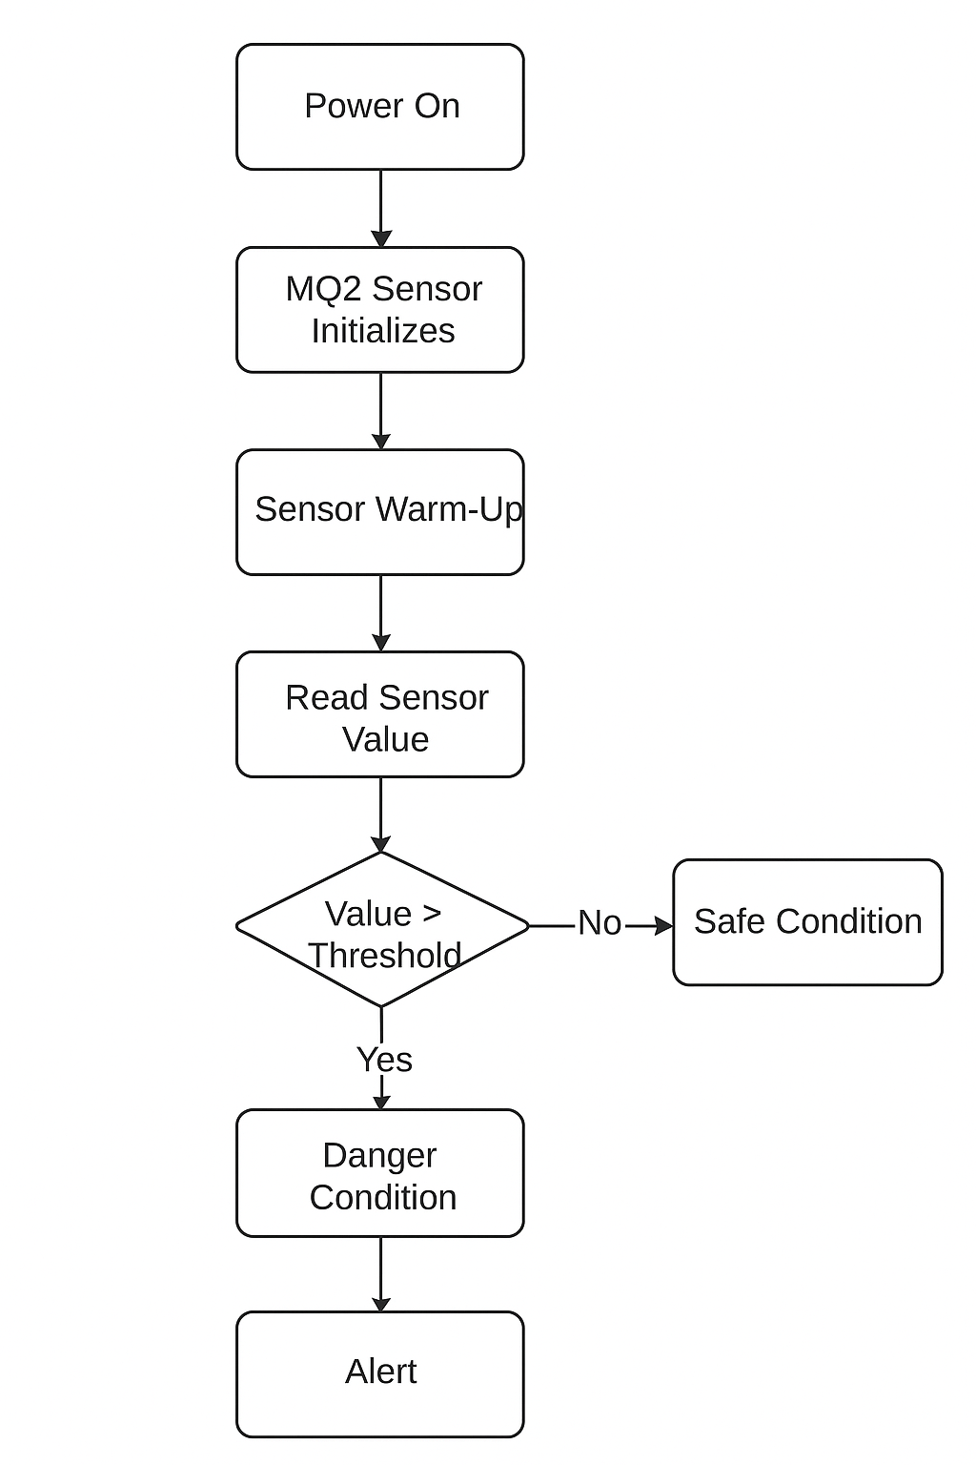

Tinkercad Circuit:
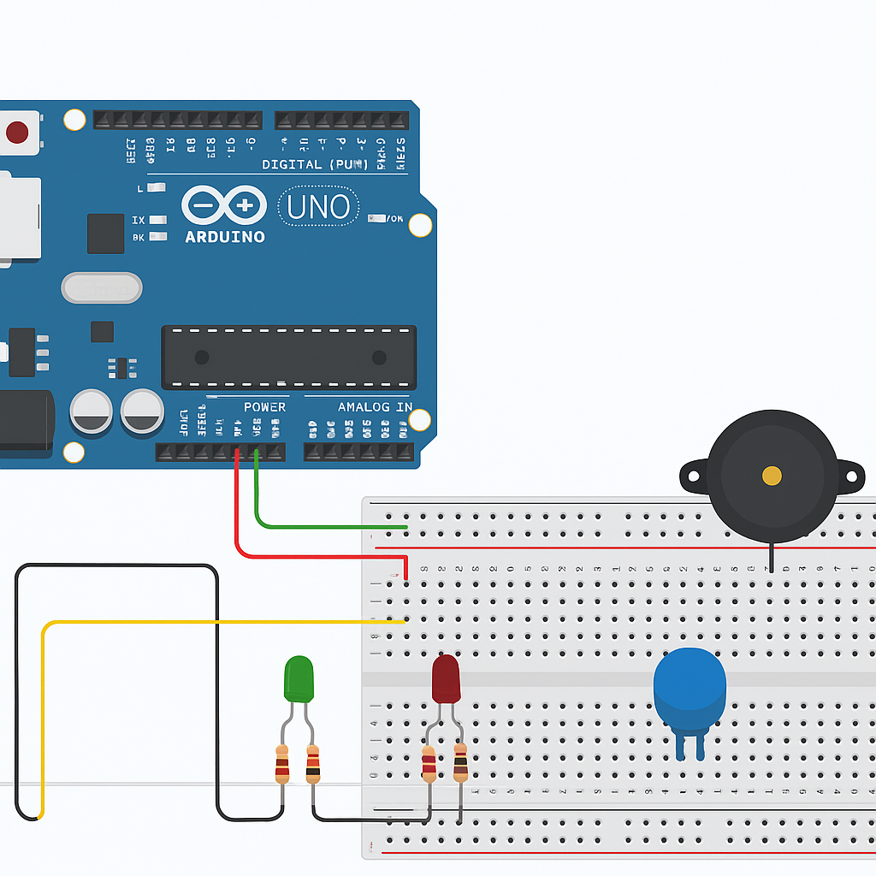

3.4. Logo Designing and Naming
The project was named “SafeAir Detector” to represent its core purpose—ensuring clean and safe air in indoor environments. The name was chosen after brainstorming several options that reflected both functionality and reliability. “SafeAir” captures the project’s essence of protecting users from invisible gas hazards, while “Detector” clearly identifies its technical nature.
The logo was designed to symbolize safety, vigilance, and technology. It features a protective shield enclosing a gas droplet, representing protection from harmful gases. The circular shape of the logo indicates continuity and monitoring, reflecting the system’s constant operation. Shades of blue and green were used to signify trust, freshness, and environmental safety, while a touch of red symbolizes alertness during danger.
Overall, the logo and name together convey the mission of the project — to create a reliable, smart, and affordable solution that safeguards homes and workplaces from gas-related hazards. The thoughtful visual identity makes the project not only technically sound but also visually recognizable and meaningfu

Implementation Plan / Methodology
The implementation phase followed a systematic and step-by-step approach to ensure proper execution of both hardware and software components. The process was divided into several stages:
- Circuit Design:
The circuit was first simulated on Tinkercad, using the Arduino Uno, MQ2 gas sensor, LEDs, and a buzzer. The virtual simulation allowed for easy debugging and visualization of the circuit’s response before hardware assembly.
- Code Development:
The Arduino program was written in the Arduino IDE, using fundamental control structures such as if-else conditions, loops, and serial communication. The code continuously reads gas concentration levels, compares them to a defined threshold, and triggers alerts accordingly.
- Testing:
Testing was carried out in a controlled environment using small bursts of LPG or lighter gas near the sensor to observe how quickly the system responds. Each test was repeated multiple times to verify accuracy and consistency.
- Calibration:
The threshold value (default = 400) was fine-tuned based on repeated tests to balance sensitivity and reliability. This calibration ensured that minor fluctuations in normal air didn’t cause false alarms.
- Documentation:
All readings, observations, and results were systematically recorded. Supporting images, graphs, and circuit screenshots from Tinkercad were included for validation and report presentation.
This structured methodology ensured that the SafeAir Detector was implemented efficiently, tested thoroughly, and documented clearly for future replication or enhancement.

Project Output

When gas is detected:

Red LED glows and buzzer sounds.
When air is clean:

Green LED glows indicating safe condition.
The Serial Monitor displays live analog readings for debugging and analysis.

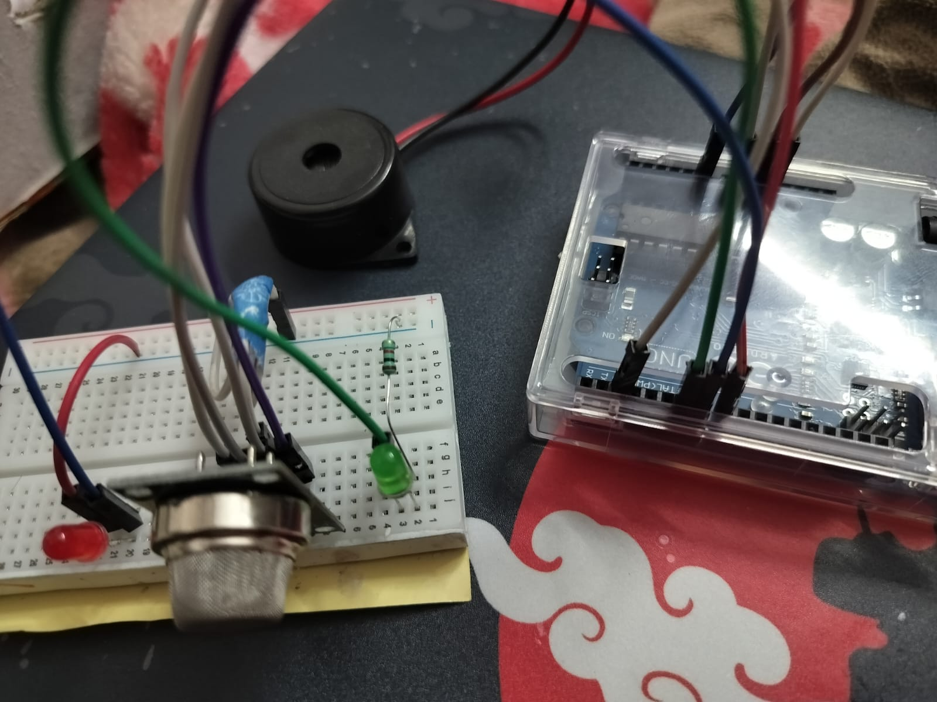
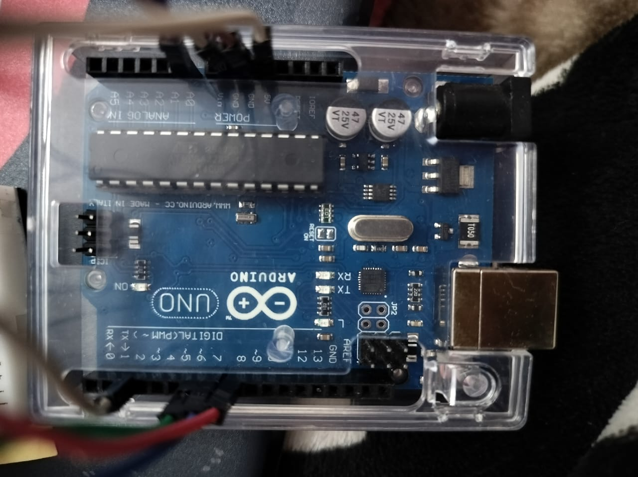

When air is safe:
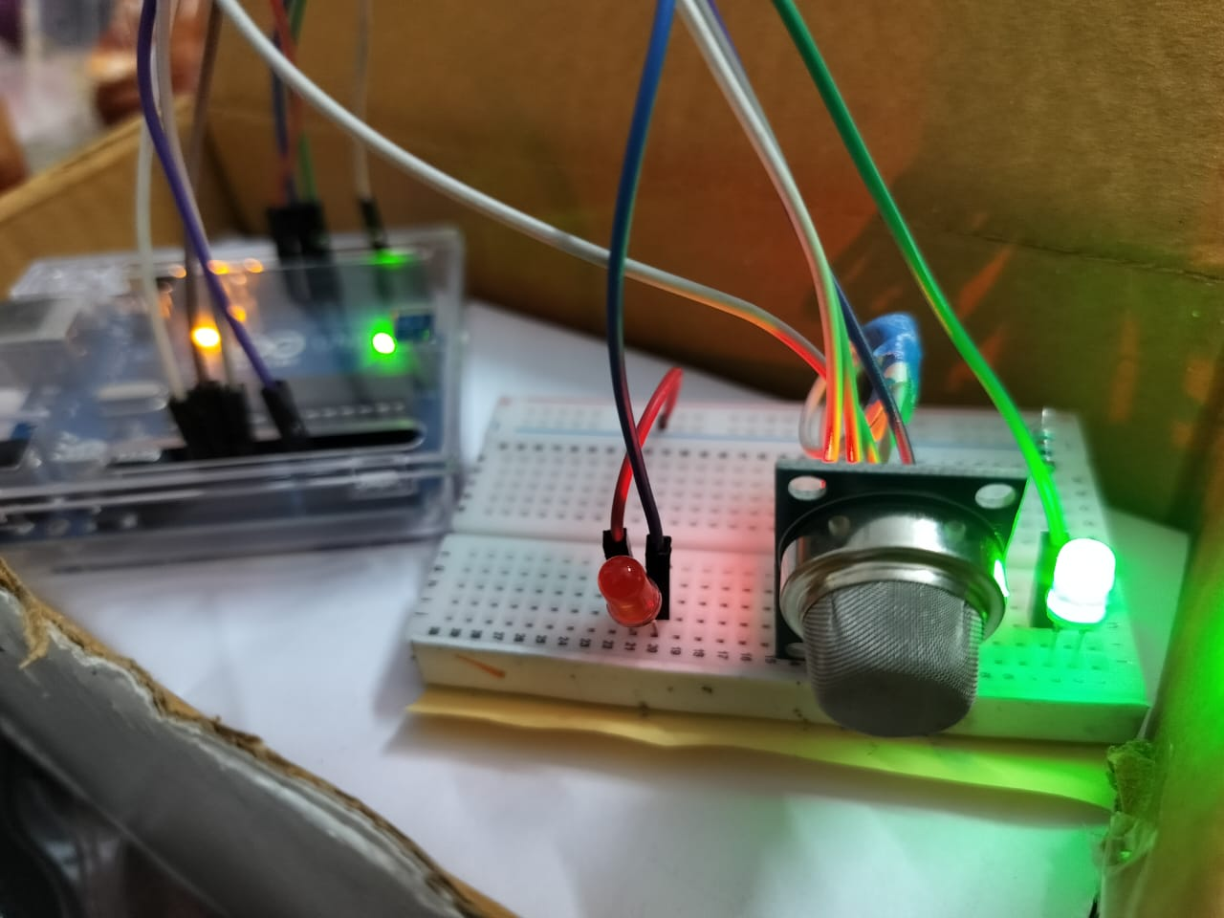

When smoke or any combustible gas is sensed by sensor:

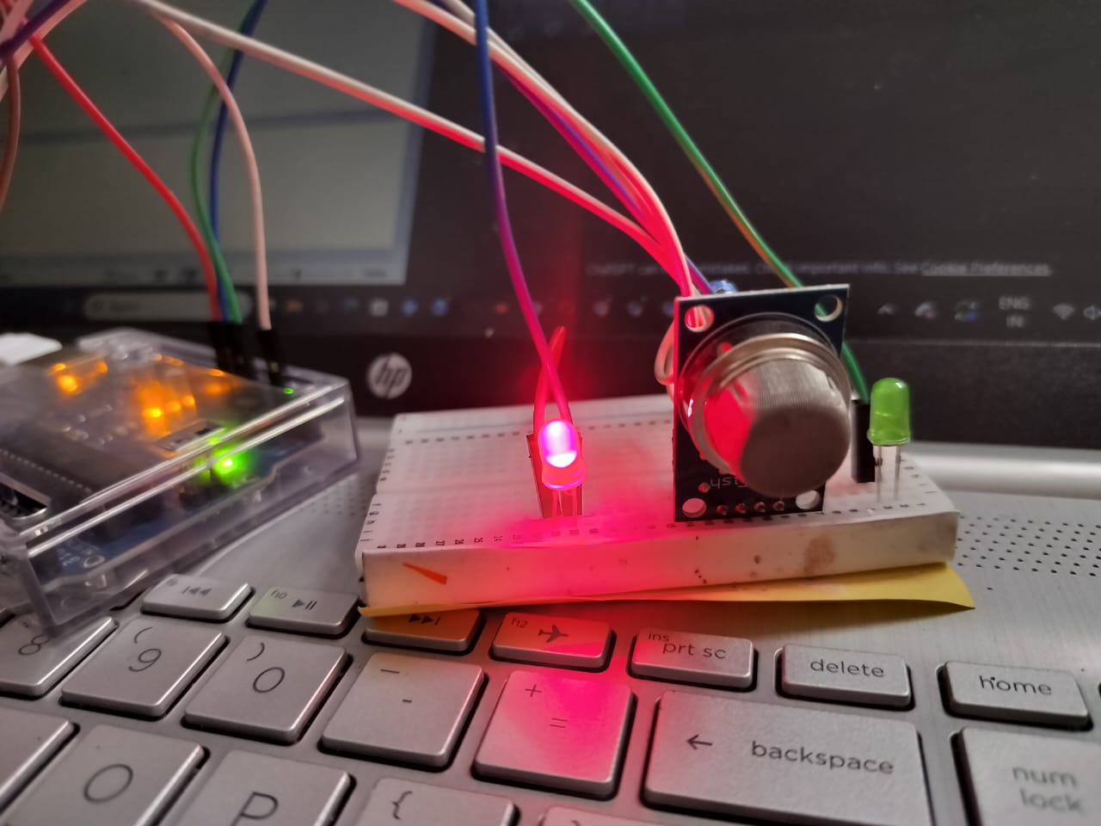

CHAPTER 4
RESULTS ANALYSIS AND VALIDATION

4.1 Implementation of Solution

The implementation phase marked the transition of the project from theory to practical execution. The circuit was carefully assembled on a breadboard using key components such as the Arduino Uno, MQ2 gas sensor, LED indicators, and a buzzer. Each component was connected according to the designed schematic, ensuring that wiring was neat, logical, and error-free. Special attention was given to the power supply lines and signal pins, as even small wiring errors could affect sensor readings or cause malfunction.

Before data collection, the MQ2 sensor underwent a warm-up period of approximately 20 seconds to allow its internal heating element to stabilize. Once warmed up, the sensor started generating consistent analog readings that represented gas concentration levels in the air. The Arduino continuously monitored this analog signal, comparing it against a predefined threshold value to determine whether the environment was safe or hazardous.

When the detected gas level exceeded the defined limit, the system immediately triggered audible and visual alerts—the red LED turned on, and the buzzer emitted a loud warning tone. In normal air conditions, the green LED glowed steadily, indicating that no gas leak was present. This simple yet effective alert mechanism made the system intuitive to use and ensured that any gas leakage was detected within seconds.

Throughout multiple testing sessions, the circuit demonstrated excellent reliability and responsiveness. It consistently provided accurate readings and quick detection even after repeated trials. The overall implementation confirmed that the design was practical, efficient, and easily reproducible for both educational and real-world applications.

4.1.1 Report Preparation
Documentation played an essential role throughout the development process. Every step—from initial circuit design to final testing—was recorded in detail to ensure transparency and clarity. During implementation, key data such as sensor readings, threshold levels, voltage values, and response times were tabulated for analysis. These data tables helped in identifying trends and validating that the system operated within expected parameters.
Screenshots from Tinkercad simulations and images of the actual breadboard circuit were included in the report to provide visual evidence of progress and successful implementation. The software code was also documented with comments to make it easy for others to understand the logic and modify it if needed.

The report was written following academic standards, maintaining a systematic flow from objectives to results. This not only enhanced readability but also ensured that anyone reviewing the work could easily trace the development stages. Moreover, the process of maintaining a detailed record helped the team identify minor issues during testing and guided improvements in calibration and coding.

4.1.2 Project Management and Communication

The project’s success was largely attributed to effective planning, teamwork, and communication. A structured weekly plan was created at the beginning, dividing the work into stages such as component testing, sensor interfacing, threshold calibration, coding, simulation, and final testing. Each task had a clear deadline and responsible team member.

Regular meetings were held to discuss progress, identify challenges, and exchange ideas. During these sessions, the team collaborated to troubleshoot issues such as sensor noise, unstable readings, or delayed buzzer response. Brainstorming helped refine the calibration process to achieve more stable and accurate detection results.

All findings and adjustments were noted in a shared log, which helped maintain accountability and ensured that no step was overlooked. This collaborative and well-structured approach ensured that all milestones—hardware assembly, software debugging, and report preparation—were completed on time. The experience not only enhanced technical skills but also strengthened teamwork, communication, and project management capabilities.

4.1.3 Testing / Characterization / Interpretation / Data Validation
The testing phase was a critical part of verifying that the system performed as intended. Controlled experiments were carried out by bringing a small source of combustible gas—such as a lighter—near the MQ2 sensor. The Arduino’s serial monitor was used to observe real-time readings. Under normal room conditions, sensor output values were generally between 200–300 units, indicating safe air quality.
As soon as gas was introduced, the sensor detected an increase in concentration, with readings spiking above 400 units. When this threshold was crossed, the system instantly activated the buzzer and illuminated the red LED, signaling danger. Once the gas source was removed and the air cleared, the sensor values gradually dropped back to the safe range, and the system automatically reset to its normal state with the green LED turning back on.
These repeated tests confirmed that the system was highly responsive, accurate, and consistent. It could reliably distinguish between safe and hazardous environments with minimal delay. Data validation also proved that the sensor calibration was effective, as the readings remained stable across multiple trials and environmental conditions.
Overall, the testing and analysis phase verified that the MQ2-based gas detection system not only met its design goals but also provided a dependable and real-time safety solution. The combination of hardware efficiency, quick response, and clear alerts made the prototype suitable for further scaling and integration into real-world applications.

4.1.4 Results Summary and Data Analysis
To validate the performance of the MQ2 gas detection system, several controlled tests were conducted in different environmental conditions. Each test was performed after the sensor’s warm-up phase to ensure stability. Readings were recorded from the Arduino Serial Monitor, and the system’s response was observed. The following table summarizes the key test results:

Test Condition | Sensor Reading (Analog Value) | System Response | Observation / Interpretation
Normal clean air | 200 – 300 | Green LED ON, Buzzer OFF | Air quality safe; system idle.
Slight gas exposure (low concentration) | 320 – 380 | No alert, only monitoring active | Air slightly impure, within safe limits.
Moderate gas exposure | 390 – 410 | Red LED flickers occasionally | Borderline condition; nearing danger threshold.
Heavy gas exposure (high concentration) | 420 – 550 | Red LED ON, Buzzer ON continuously | Hazard detected; immediate alert triggered.
Post-ventilation (air cleared) | 250 – 300 | Green LED ON, Buzzer OFF | System auto-resets; air quality restored.

Data Interpretation
From the table, it is evident that the MQ2 sensor provided clear differentiation between safe, moderate, and hazardous gas levels. The readings gradually increased with rising gas concentration, allowing the Arduino to take timely action. The threshold value of 400 was found to be optimal — it avoided false alarms during normal fluctuations while ensuring immediate response to real leaks.
The system’s response time was typically less than 2 seconds, making it fast enough for real-world detection scenarios. Once the air was cleared, the readings dropped back to normal within 10–15 seconds, confirming the circuit’s automatic reset capability. The test results validated that the prototype worked reliably under repeated trials, providing a dependable safety mechanism.
Additionally, the buzzer and LED indicators made it easy to visually and audibly understand the air status, even for non-technical users. This human-friendly interface ensures that the system can be safely deployed in households, laboratories, or small industrial environments.

CHAPTER 5 CONCLUSION AND FUTURE WORK
5.1 Conclusion
The MQ2 Gas Detection System successfully achieved its main objective of detecting harmful and flammable gases in the surrounding environment in an efficient and affordable way. The project proved that by using simple and easily available electronic components like the MQ2 sensor, Arduino Uno, LEDs, and a buzzer, it is possible to build a compact yet reliable gas monitoring system. The Arduino microcontroller acted as the brain of the project, processing the sensor data in real time and triggering alerts whenever the gas concentration exceeded the safe threshold.
During testing, the system responded instantly to the presence of gases such as LPG, methane, and propane, and it accurately switched between safe and danger modes. The green LED served as a clear indicator of normal air conditions, while the red LED and buzzer effectively signaled potential danger. This immediate feedback mechanism makes the project extremely useful for home kitchens, laboratories, and small industries where gas leaks are a common risk.
One of the major strengths of this project is its simplicity and flexibility. The circuit can be assembled easily, and the Arduino code is straightforward to modify, allowing users to adjust sensitivity or add new features. The project not only provided a practical demonstration of sensor interfacing and microcontroller programming but also highlighted how technology can directly contribute to human safety and accident prevention. Overall, this project is an excellent example of how low-cost embedded systems can be used to solve real-world safety problems effectively.
5.2 Future Work
Although the developed prototype performed well in the laboratory setup, there are several possibilities to enhance its functionality and make it more advanced. In future versions, the system can be upgraded by adding IoT (Internet of Things) capabilities.
For instance, by integrating Wi-Fi (ESP8266) or GSM modules (SIM800L), the system could send real-time alerts to users via mobile notifications or SMS whenever dangerous gas levels are detected. This improvement would make it much more useful for remote monitoring and smart home integration.
Another major enhancement would be adding an LCD or OLED display to show live gas concentration readings and system status, giving users better visibility of air quality at any time. The calibration of the MQ2 sensor can also be refined by incorporating additional sensors such as temperature and humidity modules, since these environmental factors can affect gas detection accuracy.
For a permanent setup, the entire circuit can be transferred from a breadboard to a Printed Circuit Board (PCB) to improve durability, reduce wiring errors, and give it a more professional look. Finally, future development could include a mobile or web-based dashboard to log sensor data, visualize trends, and perform predictive analysis using AI or machine learning techniques.
With these enhancements, the MQ2 Gas Detection System could evolve from a simple prototype into a fully automated IoT-based safety device suitable for homes, industries, and research institutions. Such advancements would not only improve user safety but also demonstrate how modern embedded systems can be adapted to create smarter and safer environments.

REFERENCES

- Hanwei / MQ-2 technical datasheet — full sensor specs and characteristics. Haoyue Electronics
- Pololu / MQ-2 product PDF — manufacturer-style datasheet explaining sensing material and behaviour. Pololu
- Winsen / MQ-2 Manual (MQ-2 Ver1.4) — official user manual with electrical characteristics and usage notes. Winsen Sensor
- Hanwei MQ-2 datasheet (alternate host / AllDataSheet page). All Datasheet
- SparkFun — MQ-2 (Smoke & Combustible Gas Sensor) product page and overview. SparkFun Electronics
- SparkFun MQ-2 breakout manual (PDF) — practical wiring and warm-up note. SparkFun
- Waveshare — MQ-2 sensor product/spec page (practical specs & usage tips). Waveshare
- Robot / Robu MQ-2 user manual — module-level documentation and electrical specs. Robu
- Instructables — “How to use MQ2 Gas Sensor — Arduino Tutorial” (step-by-step hobbyist guide). Instructables
- Instructables — “Interface MQ2 Gas/Smoke Sensor With Arduino — Step-by-Step” (another practical tutorial). Instructables
- Arduino Project Hub — “Arduino and MQ2 Gas Sensor” project page (example code & wiring). Arduino Project Hub
- CircuitDigest — “Interfacing MQ2 Gas Sensor with Arduino” (detailed tutorial + code). Circuit Digest
- Adafruit / Learn — Gas sensor comparison & explanation of MQ series operation (metal-oxide sensors explanation). Adafruit Learning System
- SunFounder documentation — lesson on MQ-2 with ESP32 (practical lesson for microcontroller interfacing). SunFounder Documentation
- The STEMpedia / Adafruit IO — example project: Gas monitoring dashboard with MQ-2 + Adafruit IO (IoT example). STEMpedia Education
- YouTube tutorial — “How to use MQ2 with Arduino” (video walkthrough of wiring and code). YouTube+1
- ResearchGate — “Internet of Things (IoT) Based Gas Leakage Monitoring and Alerting System with MQ-2” (research paper). ResearchGate
- IJERT — “Design of Gas Detection and Monitoring System using IoT” (multi-sensor + MQ series study). IJERT
- IJNRD / conference paper — “An IOT-Based Gas Leakage Detection Bot” (Arduino + MQ2 academic implementation). IJNRD
- TIJERC / related paper — “Gas Leak Detection And Automatic Shut-Off” (MQ-2 used in automated shut-off systems). TIJER Research Journal
- SciePub / AJST — “Development and Comparison of Arduino Based MQ-2 and MQ-6” (comparative evaluation study). Science and Education Publishing
- IJARSCT / LPG Leakage Detection using IoT — survey + implementation examples (literature review). IJARSCT
- Prime Open Access / “IoT-Based Gas Leakage Detection and Monitoring System” (recent open-access paper). Prime Open Access
- TinkerCad / example circuits & community designs (useful for simulation screenshots and validation methodology).

